Area | Autumn 1 | Autumn 2 | Spring 1 | Spring 2 | Summer 1 |  | Summer 2
Main Theme | Me and My Local Area | Inventions | People | Animals | Plants |  | Explorers
Focus Topics | Me and my local area  Autumn/ Seasons  New beginnings  My School and locality.  Our local area - Sir Walter Raleigh , Otterton Mill  My New Class – class charter/ kind hands and kind words  Ourselves - what am I good at?  My Body- How have I changed?  My Family – Where do I live?  My local area  Transport – how do I come to school?  Different forms of transport.  Child initiated topics. | Materials – build it  Winter/Seasons  Ourselves – How am I different/the same as my friends?  Inventions/ different materials  Lotions and Potions  Good to be me –who am I and what do I like?  Oral health and healthy eating- what do I like and what should I eat.  Child initiated topics.  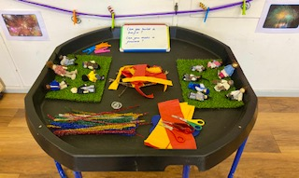 | People who help us  Weather Watch  Chinese New Year – Year of the dragon  People who help us – looking at the roles of police, dentist, lifeboat, doctors ( role play focus)  My family – talking about the past  Feelings – PHSE focus  Healthy Eating/cooking  Child initiated topics.  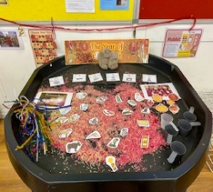 | Animals  Spring/Seasons/ weather  Plants and growing seeds  My friends – different and the same.  My pets = how to care for our pets  Role play – vets and zoo  Animals/ minibeasts  Healthy Eating/Cooking  Oral health recap  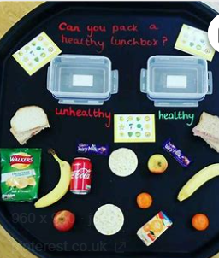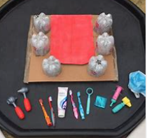  Child initiated topics.  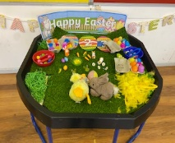 | Plants and animals  Summer/Seasons  Plants  Growing seeds  Farms  Land and sea  Child initiated topics.  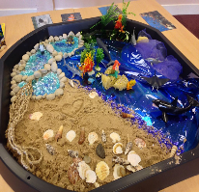  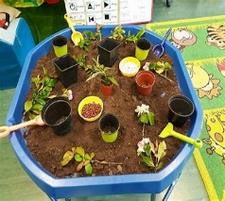 |  | The world around us  Weather Watch  Around the world- looking after our planet  Environments – beach, country and town  Farms – where does food come  Oral health recap  Child initiated topics.  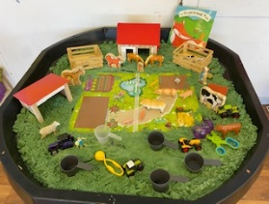
Wow Moments/ Experiences | Walk to visit local landmarks- church, park, shop, Sir Walter Raleigh statue  Otterton Mill Milling Date  Autumn leaf stomp – tree watch  Bun Day First Monday in November  Harvest Service ( Year R)  Fortnightly Open the Book (Year R)  Junk Modelling Parent Day – building vehicles  Litter Picks and Beach cleans | Winter- Tree watch  Fireworks  Remembrance day – visit to the Memorial Cross  Father Christmas at the local shop.  Christmas Play and Carols ( Pre School own songs)  Fortnightly Open the Book ( Year R) | Chinese New Year Celebration  Dentist visit to school  Police visit to school  Fire fighter visit  Coastguard visit  Fortnightly Open the Book ( Year R)  Cooking  Allotment visits  Grandparent day  Fortnightly Open the Book | Fortnightly Open the Book  Cooking- pancakes, healthy pizza healthy sandwiches, bread  Allotment visits and planting seeds  Visit to Axminster wildlife centre( R)  Parent invention day – making kites  Easter activities | Fortnightly Open the Book  Allotment visits  School Visit  Visit to the farm – looking at tractors and farm to fork  The Animal Man visit |  | Fortnightly Open the Book  Visit to the church  Allotment visits  Beach clean/visit  Cooking – soups from our own veg  Sponsored walk
Key Texts for Literacy ( See writing Progression for skills progression) | 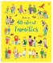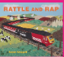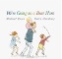 | 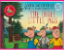 | 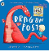 | 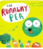 | 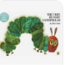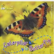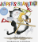 |  | 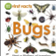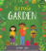
EYFS Book Spine Key Texts
See separate Book Spine
Reception  C and L | Communication and Language is developed on an ongoing basis throughout the year through high quality speaking and listening interactions, daily group discussions, sharing circles, Jigsaw/PSHE sessions, focused story sessions with book talk, singing, speech and language interventions, assemblies and weekly interventions as needed. A high priority is placed on the use and awareness of rich and new vocabulary. An environment that is word rich is valued and children are actively encouraged to play and experiment with new vocabulary.
Settling in activities and carpet times. Daily nursery rhymes and songs. Feelings puppet and mirror – moods and feelings. Adults modelling language throughout the day “Thank you!” “Good morning!” “How are you?” “Please could you pass me…?” Individual speech link assessment to set a baseline and to start referrals for those who are highlighted.
Role Play – Deconstructed and Themed
Word of the week
Focussed Storytime/ Book Talk
Daily nursery rhymes and songs
The Share Chair/ Circle Time
Role Play – Deconstructed and Themed

,
3 and 4 year olds :  C and L | Enjoy listening to longer stories and can remember much of what happens.  Pay attention to more than one thing at a time, which can be difficult.  Use a wider range of vocabulary.  Understand a question or instruction that has two parts, such as “Get your coat and wait at the door”.  Understand ‘why’ questions, like: “Why do you think the caterpillar got so fat?”  Sing a large repertoire of songs.  Know many rhymes, be able to talk about familiar books, and be able to tell a long story.  Develop their communication, but may continue to have problems with irregular tenses and plurals, such as ‘runned’ for ‘ran’, ‘swimmed’ for ‘swam’.  Develop their pronunciation but may have problems saying: - some sounds: r, j, th, ch, and sh - multisyllabic words such as ‘pterodactyl’, ‘planetarium’ or ‘hippopotamus’  Use longer sentences of four to six words  Be able to express a point of view and to debate when they disagree with an adult or a friend, using words as well as actions. • Start a conversation with an adult or a friend and continue it for many turns.  Use talk to organise themselves and their play: “Let’s go on a bus... you sit there... I’ll be the driver.”
Reception  Literacy  Word Reading/ Phonics Bug | Reception | Reception | Reception | Reception | Reception |  | Reception
Reception  Literacy  Word Reading/ Phonics Bug | Phonics Bug: Phase 2 and 3 Sets 1 to 6 Reading: Initial single sounds, oral blending, CVCs,  Phonics Bug language sessions to set 6  CEW words: to the no go I into her me be  Reciting known stories, listening to stories with attention and recall. Help children to read the sounds speedily. Ensure books are consistent with their developing phonic knowledge. | Phonic Sounds: Phonics Bug  Phase 2 recap all sets and Phase 3 Unit 7 to 9  Reading: Introducing first diagraphs  Phonics Bug language sessions to 11 plus 12 ( 1 and 2)  CEW: he my by she they we are you all was give live | Phonic Sounds: Phonics Bug Phase 3 10 and 11 and recap all Sets  Phase 4 Unit 12  Reading: Phase 4 consonant blends  Phonics Bug language sessions to  CEW: he my by she they we are you all was give live  Phase 4 :said, have, like, so, do, some, come, were, there, little, one, when, out, what | Phonic Sounds: Phonics Bug Phase 3 and 4  Reading: consonant blends  Phonics Bug language sessions to  CEW: said, have, like, so, do, some, come, were, there, little, one, when, out, what | Phonic Sounds: Phonics Bug Phase 3 and 4  Reading:  Phonics Bug language sessions to  Embed all CEW  to the no go I into her me be he my by she they we are you all was give live  said, have, like, so, do, some, come, were, there, little, one, when, out, what |  | Phonic Sounds: Phonics Bug Phase 4 and Phase 5 wh ph  Reading:  Phonics Bug language sessions to  Embed all CEW  to the no go I into her me be he my by she they we are you all was give live  said, have, like, so, do, some, come, were, there, little, one, when, out, what
3 and 4 year olds
Literacy

Word Reading/ Phonics Bug

3 and 4 year olds  Literacy  Word Reading/ Phonics Bug | Phonics Bug:  A Wet Walk Lessons 1 to 4  Alphabet song  Aspects of sounds – CP  General sound discrimination- Environmental sounds  General sound discrimination – body percussion  General sound discrimination – voice sounds  General sound discrimination – instrumental sounds  Alliteration  Rhythm and Rhyme  Oral blending and segmenting | Phonics Bug:  Al sorts of art Lessons 1 to 5  Alphabet song  Aspects of sounds – CP  General sound discrimination- Environmental sounds  General sound discrimination – body percussion  General sound discrimination – voice sounds  General sound discrimination – instrumental sounds  Alliteration  Rhythm and Rhyme  Oral blending and segmenting | Phonics Bug:  Nature Shapes Lessons 1 to 5  Alphabet song  Aspects of sounds – CP  General sound discrimination- Environmental sounds  General sound discrimination – body percussion  General sound discrimination – voice sounds  General sound discrimination – instrumental sounds  Alliteration  Rhythm and Rhyme  Oral blending and segmenting | Phonics Bug:  The Missing Button Lessons 1 to 3  Alphabet song  Aspects of sounds – CP  General sound discrimination- Environmental sounds  General sound discrimination – body percussion  General sound discrimination – voice sounds  General sound discrimination – instrumental sounds  Alliteration  Rhythm and Rhyme  Oral blending and segmenting | Phonics Bug:  From Seed to Sandwich Lessons 1 to 5  Alphabet song  Aspects of sounds – CP  General sound discrimination- Environmental sounds  General sound discrimination – body percussion  General sound discrimination – voice sounds  General sound discrimination – instrumental sounds  Alliteration  Rhythm and Rhyme  Oral blending and segmenting |  | Phonics Bug:  A day at the beach  Lesson 1 to 3  Alphabet song  Aspects of sounds – CP  General sound discrimination- Environmental sounds  General sound discrimination – body percussion  General sound discrimination – voice sounds  General sound discrimination – instrumental sounds  Alliteration  Rhythm and Rhyme  Oral blending and segmenting
3 and 4 year olds  Literacy  Word Reading/ Phonics Bug | EYFS statements:  Enjoy listening to longer stories and can remember much of what happens.  Pay attention to more than one thing at a time, which can be difficult.  Use a wider range of vocabulary.  Understand a question or instruction that has two parts, such as “Get your coat and wait at the door”.  Understand ‘why’ questions, like: “Why do you think the caterpillar got so fat?”  Sing a large repertoire of songs.  Know many rhymes, be able to talk about familiar books, and be able to tell a long story.  Develop their communication, but may continue to have problems with irregular tenses and plurals, such as ‘runned’ for ‘ran’, ‘swimmed’ for ‘swam’.  Develop their pronunciation but may have problems saying: - some sounds: r, j, th, ch, and sh - multisyllabic words such as ‘pterodactyl’, ‘planetarium’ or ‘hippopotamus’  Use longer sentences of four to six words.  Be able to express a point of view and to debate when they disagree with an adult or a friend, using words as well as actions.  Start a conversation with an adult or a friend and continue it for many turns.  Use talk to organise themselves and their play: “Let’s go on a bus... you sit there... I’ll be the driver.
Reception  Literacy  Comprehension | Daily focussed storytime with a focus on comprehension  Listening to stories.  Joining in with rhymes and repeated refrains. Environment print. Having a favourite story/rhyme. Understand the five key concepts about print: - print has meaning - print can have different purposes - we read English text from left to right and from top to bottom - the names of the different parts of a book. Sequencing familiar stories through the use of pictures to tell the story.  Recognising initial sounds.  Name writing activities.  Engage in extended conversations about stories, learning new vocabulary. | Daily focussed storytime with a focus on comprehension  Beginning to retell stories. Retell stories related to events through acting/role play. Retelling stories using images / apps.  Retelling of stories.  Editing of story maps and orally retelling new stories. Sequence story – use vocabulary of beginning, middle and end.  Enjoys an increasing range of books.  Actions to retell the story. Story Maps. | Daily focussed storytime with a focus on comprehension  Retelling stories with the recently introduced vocabulary.  Making up stories with themselves as the main character.  Encourage children to record stories through picture drawing/mark making.  Read simple phrases and sentences made up of words with known letter–sound correspondences and, where necessary, a few exception words.  Using recently introduced vocabulary during discussions about stories and during role-play. | Daily focussed storytime with a focus on comprehension  Building fluency and understanding.  Re-read books to build up their confidence in word reading, their fluency and their understanding and enjoyment.  Use vocabulary and forms of speech that are increasingly influenced by their experiences of books.  Develop their own narratives and explanations by connecting ideas or events | Daily focussed storytime with a focus on comprehension  Explaining the stories they have listened to or have read themselves.  Retell a story with actions and / or picture prompts as part of a group.  Use story language when acting out a narrative. Rhyming words.  Can explain the main events of a story.  Can draw pictures of characters/event /setting in a story. May  include labels, sentences or captions. |  | Daily focussed storytime with a focus on comprehension  Demonstrate understanding of what has been read to them  Retelling stories using their own words and recently introduced vocabulary.  Can draw pictures of characters/ event / setting in a story.  Listen to stories, accurately anticipating key events & respond to what they hear with relevant comments, questions and reactions. Make predictions.  Fiction and Non- Fiction: Beginning to understand that a non-fiction is a nonstory- it gives information instead. Fiction means story.  Point to front cover, back cover, spine, blurb, illustration, illustrator, author and title
Reception  Literacy  Writing | Representing name and initial letter sounds.  Dominant hand, tripod grip, mark making, giving meaning to marks and labelling.  Continuous Provision mark making  Using letter boards to spell Phonics Bug decodable words and Phonics Bug CEW sets 1 – 6 :  WK 1 : at as  WK 2: an, it, in, is, dad  Wk 3: can, on, not, got CEW : to  Wk 4: mum, up, get CEW: the, no, go  WK 5: had, back, his, big, him, if, of, off, but CEW: I, into, her  WK 6: Recap decodable CEW: me be  Practising correct letter formation. | Writing CVC words using letter boards then whiteboard pens .  Name writing.  Continuous Provision ongoing availability of writing materials  Supported use of Phonic Bug sound cards to label pictures etc using initial sounds.  Story scribing with an adult during role play.  Retelling stories using mapping in writing area/Tuff trays/ clip board  Sequencing the story activities and Tuff trays  Practising correct letter formation  From Unit 7 : Caption Writing.  Using letter boards (and writing) to spell Phonics Bug decodable words and Phonics Bug CEW  Continued revision of weeks 1 – 6 words  Wk 7: will CEW: he, my, by, she  Wk 8: that, this, then, them, with CEW: they  Wk 9: look, see, too CEW: we, are  Wk 10: or, now, down CEW: you  Wk 11: CEW: all, was, give, live  WK 12: went, from, children, just, help CEW: said, have, like, so, do, some, come, were, there, little, one, when, out, what | Phonic Bug Caption Writing  Writing CVC, CVCC, CCVC words.  Guided writing opportunity linked to key focus areas  around developing short sentences in a meaningful context.  Creating story boards. Practising correct letter formation.  Daily handwriting alongside Phonics Bug to practise letter formation.  Recognition and writing of CEW as per Phonics Bug schedule sets 1 to 12  Modelled writing to continue but children to be encouraged to develop independence in their segmenting , blending and writing skills using letter boards if needed,  Use of Phonic Bug sound cards prompted in all activities – guided and in Continuous Provision ongoing availability of writing materials  Display sounds and CEW for children to access around the setting  Use stem sentences to scaffold some writing.  Recap all CEW until secure  Phase 3 and 4 focus on CEW and decodable words. | Begin to write simple sentences. ‘Hold and write a sentence’. Creating own story maps  Writing captions and labels, Writing simple sentences.  Writing short sentences to accompany story maps.  Labels and captions.  Recipes  Guided writing opportunities linked to key focus areas  Continuous Provision ongoing availability of writing materials  Ensuring correct letter formation.  Ongoing assessment and revision of Phase 2 – 4.  Phase 4 focus on CEW and decodable words. | Writing simple sentences. ‘Hold and write a sentence’. Writing for a purpose in role play using phonetically plausible attempts at words, beginning to use finger spaces.  Form lower-case and capital letters correctly. Rhyming words.  Write 2 sentences.  Ensuring correct letter formation.  Simple Instructions  Use of stem sentences:  First:  Then:  Next:  Simple Stories / story mapping  A class book |  | Simple instructions  Extended stem sentences  How to instructions  My pet is________  It needs ________  It is _________  Facts – learn , recall orally and write  Animal facts  Bird of prey facts  A class book  Sequences of event  Simple stories/story mapping  Stem sentences  ‘Text writing  Descriptions  Simple recount  Poems about the beach/sea
3 and 4 year olds  Literacy  Mark Making Opportunities in CP to develop fine motor skills | EYFS statements:  Understand the five key concepts about print: - print has meaning - print can have different purposes - we read English text from left to right and from top to bottom - the names of the different parts of a book - page sequencing  Develop their phonological awareness, so that they can: - spot and suggest rhymes - count or clap syllables in a word - recognise words with the same initial sound, such as money and mother.  Engage in extended conversations about stories, learning new vocabulary  Use some of their print and letter knowledge in their early writing. For example: writing a pretend shopping list that starts at the top of the page; writing ‘m’ for mummy. Write some or all of their name  Help children to learn to form their letters accurately. First, they need a wide-ranging programme of physical skills development, inside and outdoors. Include large-muscle co-ordination: whole body, leg, arm and foot. This can be through climbing, swinging, messy play and parachute games, etc. Plan for small-muscle co-ordination: hands and fingers. This can be through using scissors, learning to sew, eating with cutlery, using small brushes for painting and pencils for drawing. Children also need to know the language of direction (‘up’, ‘down’, ‘round’, ‘back’, etc).  Mops and brushes, dustpans, paintbrushes etc  Chunky chalks  Chunky pens  Clipboards  Paper rolls  Chalkboards  Large whiteboards and chunky pens  Paper of various sizes  Card – boxes and strips  Printing – sponges, fruit and veg, found objects, utensils, string wooden spools, nature  Car and vehicle wheel tracks  Spray painting – spray bottles, shapes to fill  Pom pom printing – using pinchers  Tuff Trays track – shaving foam, slime, bubbles, gel, wet sand, dry sand, rice, food items, noodles  Play doh printing – dry objects, found objects, shapes  Loose parts - magnetics, shells, nature, found objects, pebbles, sticks, conkers etc  Upright – paints, weaving, hanging shapes, window/wall washing, paint dribbles/splatter painting
Reception  Maths  - White Rose – guided  - Continuous Provision opportunities | Getting to know you (2 weeks)  Match Sort and Compare : (2 weeks)  Step 1: Match Objects  Step 2: Match pictures and objects  Step 3: Identify an object  Step 4: Sort objects to a type  Step 5: Exploring sorting techniques  Step 6: Creating sorting rules  Step 7: Compare amounts  Tuff Tray Examples:  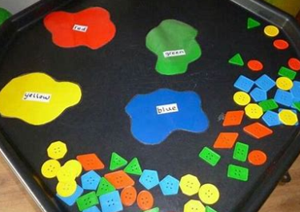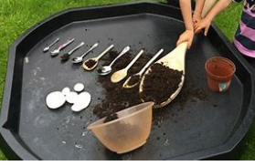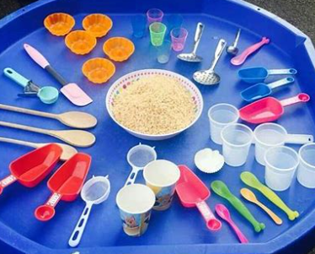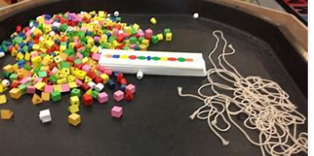  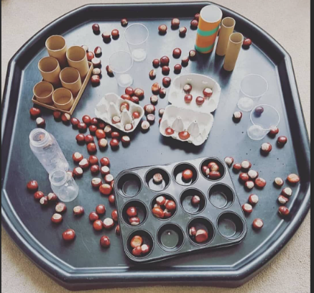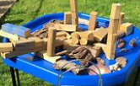  Talk about measure and patterns ( 2 weeks)  Step 1 : Compare size  Step 2: Compare Mass  Step 3: Compare capacity  Step 4: Explore simple patterns  Step 5: Copy and continue simple patterns  Step 6: Create simple patterns  Tuff Tray Examples:  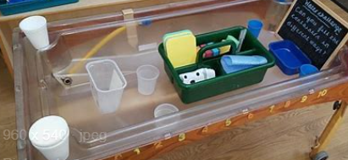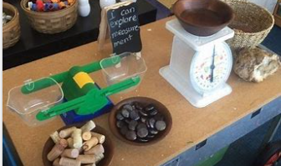  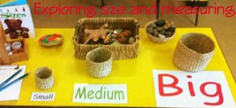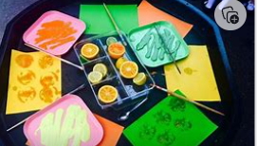 | It’s Me 1 2 3 ( 2 weeks)  Step 1: Find 1 2 and 3  Step 2: Subitise 1 2 and 3  Step 3: Represent 1 2 and 3  Step 4: 1 more  Step 5: 1 less  Step 6: Composition of 1 2 and 3  Tuff Tray Examples:  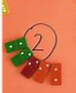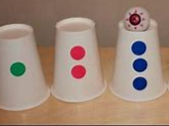  Circles and Triangles (1 week)  Step 1: Identify and name triangles and circles.  Step 2: Compare circles and triangles  Step 3: Shapes in the environment  Step 4: Describe position  Tuff Tray Examples:  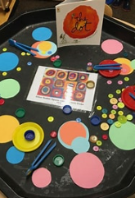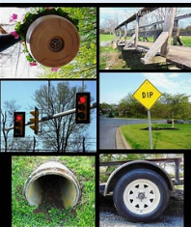  1 2 3 4 5: ( 2 weeks)  Step 1: Find 4 and 5  Step 2: Subitise 4 and 5  Step 3: Represent 4 and 5  Step 4: 1 more  Step 5: 1 less  Step 6: Composition of 4 and 5  Step 7: Composition of 1 to 5  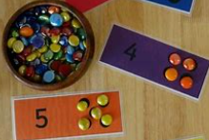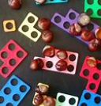  Shapes with 4 sides ( 1 week)  Step 1: Identify and name shapes with 4 sides  Step 2: Combine shapes with 4 sides  Step 3: Shapes in the environment  Step 4: My day and night  Tuff Tray Examples:  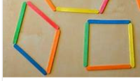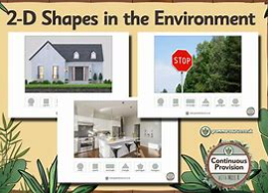 | Alive in 5: ( 2 weeks)  Step 1: Introduce 0  Step 2: Find 0 to 5  Step 3: Subitise 0 to 5  Step 4: Represent 0 to 5  Step 5: 1 more  Step 6: 1 less  Step 7: Composition  Step 8: Conceptual subitising to 5  Tuff Trays Examples:  Mass and Capacity: (1 week)  Step 1: Compare mass  Step 2: Find a balance  Step 3: Explore capacity  Step 4: Compare capacity  Tuff Trays Examples:  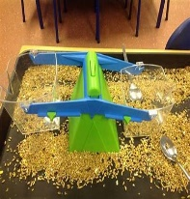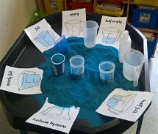  Growing 6 7 8: ( 2 weeks)  Step 1: Find 6 7 8  Step 2: Represent 6 7 8  Step 3: 1 more  Step 4: 1 less  Step 5: Composition of 6 7 8  Step 6: Make pairs – odd and even  Step 7: Double to 8 (Find a double)  Step 8: Double to 8 ( Make a double)  Step 9: Combine 2 groups  Step 10: Conceptual subitising  Tuff Tray Examples:  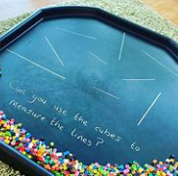  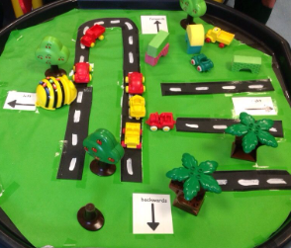  Length, Height and Time: (2 weeks spans half term)  Step 1:Explore length  Step 2: Compare length  Step 3: Explore height  Step 4: Compare height  Step 5: Talk about time  Step 6: Order and sequence time  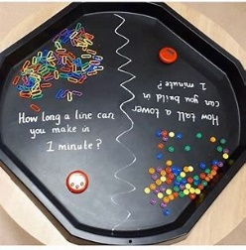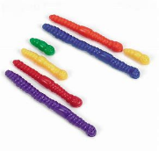 | Building 9 and 10: ( 3 weeks)  Step 1: Find 9 and 10  Step 2: Compare numbers to 10  Step 3: Represent numbers to 10  Step 4: Conceptual subitising to 10  Step 5: 1 more  Step 6 : 1 less  Step 7: Composition to 10  Step 8: Bonds to 10 ( 2 parts)  Step 9: Make arrangements to 10  Step 10: Bonds to 10 ( 3 parts)  Step 11: Doubles to 10 ( Find a double)  Step 12: Doubles to 10 ( Make a double)  Step 13: Explore odd and even  Tuff Tray Examples:  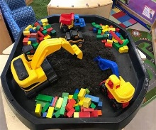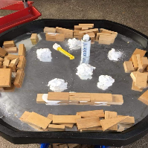  Explore 3 D shapes (2 weeks)  Step 1:Recognise and name 3D shapes  Step 2: Find 2D shapes within 3D shapes  Step 3: Use 3D shapes for tasks  Step 4: 3D shapes in the environment  Step 5: Identify more complex patterns  Step 6: Copy and continue patterns  Step 7: Patterns in the environment  Tuff Tray Examples:  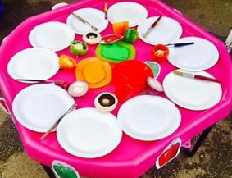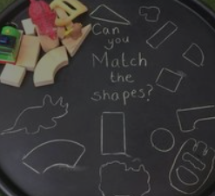 | To 20 and beyond: ( 2 weeks)  Step 1: Build numbers beyond 10 ( 10 to 13)  Step 2: Continue patterns beyond 10 ( 10 to 13)  Step 3: Build numbers beyond 10 ( 14 to 20)  Step 4: Continue patterns beyond 10 ( 14 to 20)  Step 5: Verbal counting beyond 20  Step 5: Verbal counting patterns  Tuff Tray Examples:  How many More ( 1 week)  Step 1: Add more  Step 2: How many did I add?  Step 3: Take away  Step 4: How many did I take away?  Tuff Tray Examples:  Manipulate, compose and decompose ( 2 weeks):  Step 1: Select shapes for a purpose  Step 2: Rotate shapes  Step 3: Manipulate shapes  Step 4: Explain shape arrangements  Step 5: Compose shapes  Step 6: Decompose shapes  Step 7: Copy 2D shape pictures  Step 8: Find 2D shapes within 3D shapes  Tuff Tray Examples:  Sharing and grouping ( 2 weeks )  Step 1: Explore sharing  Step 2: Sharing  Step 3: Explore grouping  Step 4: Grouping  Step 5: Even and odd sharing  Step 6: Play with and share doubles  Tuff Tray Examples:  :  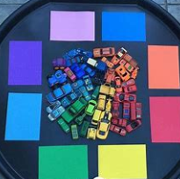 |  | Visualise Build and Map ( 3 weeks)  Step 1: Identify units of repeating patterns  Step 2: Create own pattern rules  Step 3: Explore own pattern rules  Step 4: Replicate and build scenes and constructions  Step 5: Visualise form different positions  Step 6: Describe positions  Step 7: Give instructions to build  Step 8: Explore mapping  Step 9 : Represent masp with models  Step 10: Create own maos from familiar places  Step 11: Create and plan own maps from story situations  Tuff Tray Examples:  Make connections ( 1 week)  Step 1: Deepen understanding  Step 2: Patterns and relationships  Tuff Tray Examples:  Consolidation
3 and 4 year olds  Maths | EYFS Statements:  Develop fast recognition of up to 3 objects, without having to count them individually (‘subitising’).  Recite numbers past 5.  Say one number for each item in order: 1,2,3,4,5.  Know that the last number reached when counting a small set of objects tells you how many there are in total (‘cardinal principle’).  Show ‘finger numbers’ up to 5.  Link numerals and amounts: for example, showing the right number of objects to match the numeral, up to 5  Experiment with their own symbols and marks as well as numerals.  Solve real world mathematical problems with numbers up to 5.  Compare quantities using language: ‘more than’, ‘fewer than’.  Talk about and explore 2D and 3D shapes (for example, circles, rectangles, triangles and cuboids) using informal and mathematical language: ‘sides’, ‘corners’; ‘straight’, ‘flat’, ‘round’.  Understand position through words alone – for example, “The bag is under the table,” – with no pointing.  Describe a familiar route.  Discuss routes and locations, using words like ‘in front of’ and ‘behind’.  Make comparisons between objects relating to size, length, weight and capacity  Select shapes appropriately: flat surfaces for building, a triangular prism for a roof, etc.  Combine shapes to make new ones – an arch, a bigger triangle, etc  Talk about and identifies the patterns around them. For example: stripes on clothes, designs on rugs and wallpaper. Use informal language like ‘pointy’, ‘spotty’, ‘blobs’, etc.  Extend and create ABAB patterns – stick, leaf, stick, leaf.  Notice and correct an error in a repeating pattern.  Begin to describe a sequence of events, real or fictional, using words such as ‘first’, ‘then..
Reception:  Science EYFS curriculum  Reception Matrices | Materials including changing materials  Building and construction |  | Humans People who help us  Weather and Seasons Seasonal Changes |  |  | Animals  Living things and their habitats At the Seaside
3 and 4 Year olds  Science EYFS curriculum  Nursery Matrices | Materials including changing materials  Building and Construction |  | Humans People who help us |  |  | Animals Farms  Plants
Reception : Understanding the World  Past and Present: | Past and Present:  How I have grown. My family. Ourselves – parts of the body. Our school. Role play – home setting. Their past and their life as a baby  My local area – landmarks and their history. E.g The Memorial Cross and Sir Walter Raleigh statue | Past and Present:  Can talk about what they have done with their families during Christmas’ in the past. Show photos of how Christmas used to be celebrated in the past. | Past and Present:  Roles of different jobs around us. What jobs do our family members do?  How people help us.  Jobs in the past – knights, inventors  Grandparents – visits to school to talk about their lives | Past and Present:  My pet  What pets do my family have – data collection.  Farm visit – farm machinery | Past and Present:  Local history |  | Past and Present:  Puppet shows  Space / air Travel – the first aeroplane – looking at ways we travel today and in the past.
Reception:  Understanding the World  People Culture and Communities | Describing their environment around them. Can they locate their home on google maps? Exploring what makes a family. The varying members of a family unit.  Locality – different houses. | Links to festivals: Bonfire night Diwali Christmas Role play – Christmas home scene. Cultural Events – Halloween (Trick or Treat), Bonfire Night, Remembrance Sunday, Christmas, Diwali. | Chinese New Year – how is it celebrated? How is it different to New Year here? Celebrating our differences. Significant cultural events: Pancake Day Easter Mother’s Day | The life of a farmer  Farm to fork – how our food gets to our plates. | Planting seeds  Allotment weekly |  | Looking after our planet – beach clean  Space  Picking up litter and recycling .
Reception:  Understanding the World  The Natural World | Materials:  Page 39 – 45 Science  Naming, sorting and grouping different materials according to named criteria.  Building with found objects.  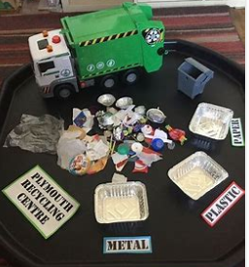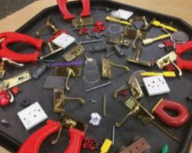 | Materials:  Page 45 – 47 Science  Farm to fork – where does our food come from?  Printing with different food types | Humans:  Page 48 – 59 Science  Space travel – Neil Armstrong and Amelia Earhart  Planets | Animals:  Page 48 – 59 Science  Looking at different kinds of animals  My Pet – photos and link to literacy ‘ How to care for a …’ posters | Living Things:  Page 33 – 35 science  Animals in the locality, Nocturnal animals – making sense of habitats. Which animals are nocturnal  Minibeast hunts.  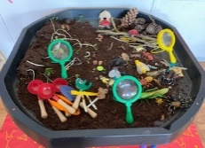 |  | Plants:  Page 36 – 38 Science  Planting seeds, examining different leaves and types of trees, Flower pressing, leaf rubbings, bark rubbings,
3 and 4 Year Olds :  Understanding the World | EYFS statements:  Use all their senses in hands-on exploration of natural materials.  Explore collections of materials with similar and/or different properties.  Talk about what they see, using a wide vocabulary.  Begin to make sense of their own life-story and family’s history.  Show interest in different occupations.  Explore how things work.  Plant seeds and care for growing plants.  Understand the key features of the life cycle of a plant and an animal.  Begin to understand the need to respect and care for the natural environment and all living things.  Explore and talk about different forces they can feel.  Talk about the differences between materials and changes they notice.  Continue developing positive attitudes about the differences between people.  Know that there are different countries in the world and talk about the differences they have experienced or seen in photos.
Reception:  Physical Development | PE: Fundamental movements and Gymnastics  Continuous Provision: Scooters and bikes, bats and balls, climbing frame, team and playtime games, parachute games, running, jumping.  Using a range of tools to develop good control – mark making areas | PE: Fundamental movements and Gymnastics  Continuous Provision: Scooters and bikes, bats and balls, climbing frame, team and playtime games, parachute games, running, jumping.  Using a range of tools to develop good control – mark making areas  Use one-handed tools and equipment, for example, making snips in paper with scissors. | PE: Throwing and Catching, passing and receiving  Continuous Provision: Scooters and bikes, bats and balls, climbing frame, team and playtime games, parachute games, running, jumping, dancing, hopping, skipping and climbing  Use one-handed tools and equipment, for example, making snips in paper with scissors.  Using tools to create with intention. | PE: Throwing and Catching, passing and receiving  Continuous Provision: Scooters and bikes, bats and balls, climbing frame, team and playtime games, parachute games, running, jumping, dancing, hopping, skipping and climbing  Develop overall body-strength, balance, coordination and agility  Use a comfortable grip with good control when holding pens and pencils  Develop their small motor skills so that they can use a range of tools competently, safely and confidently.  Use their core muscle strength to achieve a good posture when sitting at a table or sitting on the floor. . | PE: Team building and problem solving , Athletics  Continuous Provision: Scooters and bikes, bats and balls, climbing frame, team and playtime games, parachute games, running, jumping, dancing, hopping, skipping and climbing, quoits, hoops, skipping ropes, obstacle courses  Develop overall body-strength, balance, coordination and agility  Hold a pencil effectively in preparation for fluent writing - using the tripod grip in almost all cases.  Use a range of small tools, including scissors, paintbrushes and cutlery.  Begin to show accuracy and care when drawing |  | PE: Team building and problem solving , Athletics  Continuous Provision: Scooters and bikes, bats and balls, climbing frame, team and playtime games, parachute games, running, jumping, dancing, hopping, skipping and climbing, quoits, hoops, skipping ropes, obstacle courses  Develop overall body-strength, balance, coordination and agility  Hold a pencil effectively in preparation for fluent writing - using the tripod grip in almost all cases.  Use a range of small tools, including scissors, paintbrushes and cutlery.  Begin to show accuracy and care when drawing
3 and 4 year olds:  Physical Development | EYFS statements:  Continue to develop their movement, balancing, riding (scooters, trikes and bikes) and ball skills.  Go up steps and stairs, or climb up apparatus, using alternate feet.  Skip, hop, stand on one leg and hold a pose for a game like musical statues.  Use large-muscle movements to wave flags and streamers, paint and make marks.  Start taking part in some group activities which they make up for themselves, or in teams.  Increasingly able to use and remember sequences and patterns of movements which are related to music and rhythm.  Match their developing physical skills to tasks and activities in the setting. For example, they decide whether to crawl, walk or run across a plank, depending on its length and width.  Choose the right resources to carry out their own plan. For example, choosing a spade to enlarge a small hole they dug with a trowel.  Collaborate with others to manage large items, such as moving a long plank safely, carrying large hollow blocks.  Use one-handed tools and equipment, for example, making snips in paper with scissors.  Use a comfortable grip with good control when holding pens and pencils.  Show a preference for a dominant hand.  Be increasingly independent as they get dressed and undressed, for example, putting coats on and doing up zips
Reception:  PSHE | Self-Regulation:  Throughout the year children will work towards simple goals, being able to wait to wait for what they want and control their immediate impulses when appropriate. Give focused attention to what the teacher says, responding appropriately even when engaged in activity, and show an ability to follow instructions involving several ideas or actions.  * Controlling own feeling and behaviours.  * Able to concentrate on a task  * Applying personalised strategies to return to a state of calm.  * Able to ignore distractions.  * Thinking before acting.  * Able to curb impulsive behaviours.  * Behaving in ways that are socially acceptable.  * The ability to persist and persevere. |  |  |  |  |  | Show an understanding of their own feelings and those of others, and begin to regulate their behaviour accordingly. Set and work towards simple goals, being able to wait for what they want and control their immediate impulses when appropriate.
Reception:  PSHE | Managing Self:  New Beginnings. See themselves as a valuable individual. Being me in my world. Class Rule Rules and Routines. Supporting children to build relationships. | Managing Self:  Getting on and falling out. How to deal with anger Emotions. Self - Confidence Build constructive and respectful relationships. Ask children to explain to others how they thought about a problem or an emotion and how they dealt with it. | Managing Self:  Good to be me. Feelings. Learning about qualities and differences. Celebrating differences Identify and moderate their own feelings socially and emotionally. Encourage them to think about their own feelings and those of others by giving explicit examples of how others might feel in particular scenarios. | Managing Self: Relationships. What makes a good friend? Healthy me. Random acts of Kindness. Looking after pets. Looking After our Planet. Give children strategies for staying calm in the face of frustration. Talk them through why we take turns, wait politely, tidy up after ourselves and so on. | Managing Self:  Looking after others. Friendships. Dreams and Goals. Show resilience and perseverance in the face of challenge. Discuss why we take turns, wait politely, tidy up after ourselves and so on. |  | Taking part in sports day. Winning and losing. Changing me - Look how far I've come!  Be confident to try new activities and show independence, resilience and perseverance in the face of challenge. Explain the reasons for rules, know right from wrong and try to behave accordingly. Manage their own basic hygiene and personal needs, including dressing, going to the toilet and understanding the importance of healthy food choices
Reception:  PSHE | JIGSAW:  Being Me in My World  Piece 1 – Who…Me?  Piece 2 – How Am I Feeling Today?  Piece 3 – Being at School Piece 4 – Gentle Hands Piece 5 – Our Rights  Piece 6 – Our Responsibilities | JIGSAW:  Celebrating Differences  Piece 1 What I Am Good a  Piece 2 – I’m Special, I’m Me!  Piece 3 – Families  Piece 4 – Houses and Homes  Piece 5 – Making Friends  Piece 6 – Standing Up For Yourself | JIGSAW:  Dreams and Goals  Piece 1 – Challenge  Piece 2 – Never Giving Up  Piece 3 – Setting a Goal Piece 4 – Obstacles and Support  Piece 5 – Flight to the Future  Piece 6 – Award Ceremony | JIGSAW:  Healthy Me  Piece 1 – Everybody’s Body! Piece 2 – We Like to Move It, Move it!  Piece 3 – Food Glorious Food  Piece 4 – Sweet Dreams Piece 5 – Keeping Clean Piece 6 – Stranger Danger | JIGSAW:  Relationships  Piece 1 – My Family and Me!  Piece 2 – Make Friends, Never Ever Break Friends! Part 1  Piece 3 – Make Friends, Never Ever Break Friends! Part 2  Piece 4 – Falling Out and Bullying Part 1  Piece 5 – Falling Out and Bullying Part 2  Piece 6 – Being the Best Friend We Can Be |  | JIGSAW:  Changing Me  Piece 1 – My Body  Piece 2 – Respecting My Body  Piece 3 – Growing Up  Piece 4 – Fun and Fears Piece 5 – Fun and Fears Piece 6 – Celebration
Reception:  PSHE | Building Relationships: Throughout the year children will work towards forming relationships with the adults and their peers. They will begin to understand how relationships are formed and show an ability to show sensitivity to other’s needs. Playing both team games and board games play an important role in the Reception year. This enables the children to understand turn taking and working cooperatively. |  |  |  |  |  | Work and play cooperatively and take turns with others. Form positive attachments to adults and friendships with peers. Show sensitivity to their own and to others’ needs
3 and 4 year olds  PSHE | EYFS statements:  Select and use activities and resources, with help when needed. This helps them to achieve a goal they have chosen or one which is suggested to them.  Develop their sense of responsibility and membership of a community.  Become more outgoing with unfamiliar people, in the safe context of their setting.  Show more confidence in new social situations.  Play with one or more other children, extending and elaborating play ideas.  Help to find solutions to conflicts and rivalries. For example, accepting that not everyone can be Spider-Man in the game, and suggesting other ideas.  Increasingly follow rules, understanding why they are important.  Remember rules without needing an adult to remind them.  Develop appropriate ways of being assertive.  Talk with others to solve conflicts.  Talk about their feelings using words like ‘happy’, ‘sad’, ‘angry’ or ‘worried’.  Understand gradually how others might be feeling.  Be increasingly independent in meeting their own care needs, e.g. brushing teeth, using the toilet, washing and drying their hands thoroughly.  Make healthy choices about food, drink, activity and toothbrushing
Reception:  Expressive Art and Design | Creating with Materials:  Mark making with a variety of materials to include: pencil, chunky felt tips, crayons, ready mix paint, printing.  Autumn treasures station to create themed pictures.  Collage with Autumn Leaves e.g lions.  Painting buses, vehicles etc  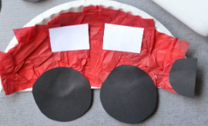  Junk modelling – creating vehicles – parent day  Tuff Trays: Autumn items, Animal craft plates,  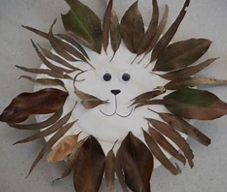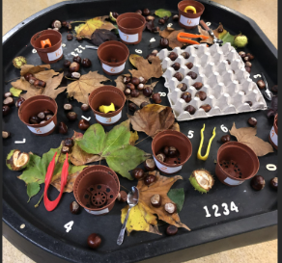 | Creating with Materials:  Printing with found objects, vegetables fruit and plants (leaves) Autumn leaf prints and rubbings.  Christmas craft / cards – stick Christmas cards  Exploring colours and colour mixing.  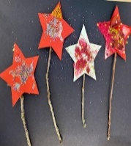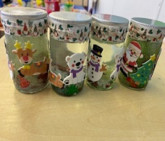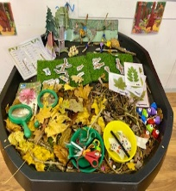 | Creating with Materials:  Building with found objects – stick picture frames.  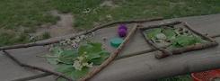 | Creating with Materials:  Printing with different foods.  Designing cookie covers  Tuff Tray-  Doh station – creating doh by following a recipe  Animal creations, animal craft and collage.  Easter craft activities | Creating with Materials:  Printing with found objects and seed.  Wildflower tiles  Flower pressing. Looking at favourite colours. |  | Creating with Materials:  Safely use and explore a variety of materials, tools and techniques, experimenting with colour, design, texture, form and function.  Share their creations, explaining the process they have used.
3 and 4 year:  Expressive Art and Design | EYFS Statements:  Take part in simple pretend play, using an object to represent something else even though they are not similar.  Begin to develop complex stories using small world equipment like animal sets, dolls and dolls houses, etc.  Make imaginative and complex ‘small worlds’ with blocks and construction kits, such as a city with different buildings and a park.  Explore different materials freely, to develop their ideas about how to use them and what to make.  Develop their own ideas and then decide which materials to use to express them.  Join different materials and explore different textures.  Create closed shapes with continuous lines, and begin to use these shapes to represent objects.  Draw with increasing complexity and detail, such as representing a face with a circle and including details.  Use drawing to represent ideas like movement or loud noises.  Show different emotions in their drawings and paintings, like happiness, sadness, fear, etc.  Explore colour and colour-mixing.  Listen with increased attention to sounds.  Respond to what they have heard, expressing their thoughts and feelings.  Remember and sing entire songs.  Sing the pitch of a tone sung by another person (‘pitch match’).  Sing the melodic shape (moving melody, such as up and down, down and up) of familiar songs.  Create their own songs, or improvise a song around one they know.  Play instruments with increasing control to express their feelings and ideas.
 | Being Imaginative and expressive:  Role Play: Journeys, train station, travel agents, space station/rockets, bus station  Tuff Trays: landscapes to promote role play  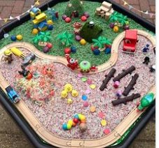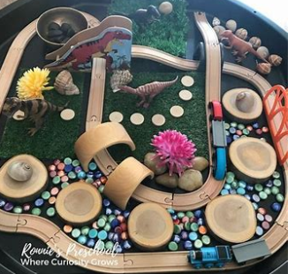 | Being Imaginative and expressive:  Role Play: Garden Centre, Witches kitchen, Christmas  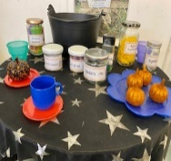 | Being Imaginative and expressive:  Role Play: potions and lotions , experiments, Doctors surgery/opticians other people who help us themed role play. | Being Imaginative and expressive:  Role Play: potions and lotions , experiments, Zoo | Being Imaginative and expressive:  Role Play: vets. Pet shop, dog groomers |  | Being Imaginative and expressive:  Role Play: Seaside theme outdoor role play inc puppet theatre
Reception Assessment | National Baseline  Phonics Baseline in score  Phonic Bug Baseline: p 31 s a t p i n m d  Week 3 assessment: p 35 s a t p i n m d  Phonics Bug End of phase 2 assessment week 5:  Names and sounds of the alphabet; Writing letters (stop after 19 letters) p 40 - 41  s, a, t, p, i, n, m, d, g, o, c, k, ck, e, u, r, h, b, f, ff l, ll, ss  Blending real words  Blending pseudo-words  Tricky words  O P & L milestones and spotlights  Tapestry ongoing assessments and flags  Ongoing reading records | Half termly screening – interim and next steps set  Out Score at end of term.  Phonics Bug End of phase 2 assessment if not done in Autumn  Phonics Bug End of Phase 3 assessment week 11 p 40-44  Names and sounds of the alphabet from 20–26: j, v, w, x, y, z, q Sounds and spellings of digraphs and trigraphs zz, qu, ch, sh, th, ng, ai, ee, igh, oa, oo (long), oo (short), ar, or, ur, ow, oi, ear, air, ure, er  Blending real words Blending pseudo-words Segmenting CVC words Tricky words  O P & L milestones and spotlights  Tapestry ongoing assessments and flags  Ongoing reading records | Spring Term screening – in score Phonics Bug end of phase 3 assessment if not completed in week 11/12 or needs to be re done.  Phase 4 assessment p 45 - 46  CVCC, CCVC, CCVCC, CCCVCC Tricky words  Blending and segmenting CCVC, CVCC and CCVCC words  O P & L milestones and spotlights  Tapestry ongoing assessments and flags  Ongoing reading records | Half termly screening – interim score and next steps set.  Phase 4 assessment if not completed in Spring 1 or needs to be redone  Continue with assessment as needed/ nurture groups  Out score at end of the term.  Phonics Bug Assessments  O P & L milestones and spotlights  Tapestry ongoing assessments and flags  Ongoing reading records | Summer term screening – in score  Continue with assessment as needed/ nurture groups  Phonics Bug Assessments  O P & L milestones and spotlights  Tapestry ongoing assessments and flags  Ongoing reading records |  | Half termly screening – interim score and next steps set.  End of year judgements.  Phonics Bug Assessments  O P & L end judgements  Tapestry ELG assessments and judgements
3 and 4 year olds  Check points /Assessment | Milestones  Opal works on the basis of having very simple, six-monthly child developmental milestones, which we use to monitor children’s development. These milestones reflect what we believe a ‘typical’ child, should be able to achieve. When looking at the statements, we assess if the child has met the milestones and record a simple ‘yes’ or ‘not yet’. We know that not all children will have ‘typical’ development. Opal allows us to tell and celebrate each child’s story and focus on the support they need from us.  An O P & L Spotlight is completed at the end of the month.  Actions will be planned to promote thinking and learning to support the child’s development.  The whole team looks at what is next for children .  This is reviewed 6 months later and the plans set are evaluated.  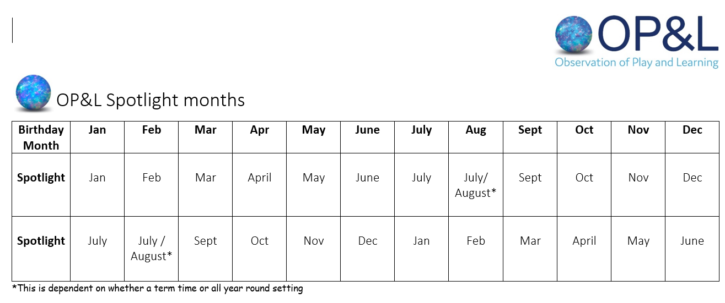  See attached O P and L checkpoints.

